Food Image Classification and Anomaly Detection Using Transfer Learning and Autoencoders
Gabriela Bermudez
Applied Data Science, School of Information Studies
Syracuse University
Daylin Hernandez
Applied Data Science, School of Information Studies
Syracuse University

Abstract
In this study, we built a deep learning system to classify food images and detect unusual items using both supervised and unsupervised methods. For classification, we used transfer learning with MobileNetV2 to recognize different food categories. For anomaly detection, we trained an autoencoder on healthy foods to flag items that look different from the training data. Using the Fruits-360 dataset, we achieved high accuracy and showed that reconstruction error can help identify outliers. To make the system easy to use, we created a Streamlit app where users can upload images, get predictions, see reconstruction results, and receive alerts for possible anomalies. This approach shows promise for real-world use in food tracking and quality control.

1. Introduction
The classification of food images has meaningful applications in nutrition tracking, healthcare diagnostics, dietary monitoring, and automated food inventory systems. Traditional computer vision methods based on handcrafted features struggle to generalize across diverse food textures and shapes. In contrast, convolutional neural networks (CNNs) have emerged as a powerful solution, offering scalable, end-to-end feature extraction and classification. “As LeCun et al. [1] explain, deep learning models enable powerful, multi-layered feature extraction that surpasses traditional handcrafted methods.”
This paper presents a hybrid approach to food image analysis using both transfer learning and unsupervised learning techniques. First, a CNN-based classifier is developed using MobileNetV2, which provides a lightweight, high-performance architecture pretrained on ImageNet and fine-tuned on the Fruits-360 dataset to perform multi-class food classification. The MobileNetV2 architecture is designed for computational efficiency and uses inverted residuals and linear bottlenecks to maintain representational power with fewer parameters [2]. Second, a convolutional autoencoder is trained solely on healthy food items to detect anomalies through reconstruction loss. Items such as red cabbage or beans, which fall outside the autoencoder’s training distribution, show a higher reconstruction error and can be flagged as anomalous.
To enhance the accessibility and usability of our models, we implemented a real-time web application using Streamlit. The app allows users to upload images, view classification predictions with confidence scores, observe the autoencoder’s reconstruction, and receive feedback on whether the food item appears familiar or potentially anomalous. This integrated approach bridges model development with user-facing implementation, which offers insights into how AI tools can support food quality assessment and health-conscious decision-making.

2. Dataset Description
The Fruits-360 dataset is a publicly available collection of high-resolution RGB images representing a wide variety of fruits and vegetables taken in controlled environments to support machine learning experiments in food recognition [4]. It comprises a total of 137,104 images, with 102,790 designated for training and 34,314 for testing, spanning across 201 distinct categories. Each image is centered, isolated, and standardized, making the dataset ideal for both classification and anomaly detection tasks.
Figure 1: Sample images from different classes in Fruits-360.

For our experiments, images were resized to 224×224 pixels for use with the MobileNetV2 classifier and 64×64 pixels for training the convolutional autoencoder. A curated subset of visually consistent and nutritionally “healthy” items, such as Banana and Apple Golden 1, was used to train the autoencoder. Conversely, items not included in this healthy subset, including Beans 1 and Cabbage red 1, were treated as anomalous during testing to evaluate the model’s capacity for out-of-distribution detection. The dataset is accessible via Kaggle at the Fruits-360 Dataset.
3. Methodology
3.1 Data Preprocessing and Augmentation
To enhance generalizations and simulate natural variability in food appearance, we applied a range of image augmentation techniques during model training. These included random rotations (±20 degrees), horizontal flipping, zoom scaling (±20%), and width/height shifts (up to 10%). All images were also rescaled to normalize pixel values within the [0, 1] range. These transformations were implemented using TensorFlow’s ImageDataGenerator, which enabled dynamic augmentation during each training epoch. This strategy proved effective in reducing overfitting and improving model robustness across diverse fruit classes.
3.2 Transfer Learning with MobileNetV2
MobileNetV2 is a lightweight convolutional neural network designed for fast and efficient performance on mobile and edge devices. It uses special building blocks called inverted residuals with linear bottlenecks, which help reduce model size and speed up processing without losing accuracy [2]. In our project, we used a version of MobileNetV2 that was already trained on the ImageNet dataset to take advantage of its ability to recognize general visual patterns. We kept the base model frozen (unchanged) and added a custom classification head that included:
- A GlobalAveragePooling2D layer to reduce the image dimensions,
- A Dense layer with 128 units and ReLU activation,
- A final Dense layer with softmax activation to output class probabilities.
We compiled the model using the Adam optimizer with a learning rate of 0.0001 and used categorical cross-entropy as the loss function. The model was trained for 10 epochs on the Fruits-360 dataset with the following setup:
base_model = MobileNetV2(input_shape=(224, 224, 3), include_top=False, weights='imagenet')
base_model.trainable = False
model.fit(train_data, validation_data=test_data, epochs=10)

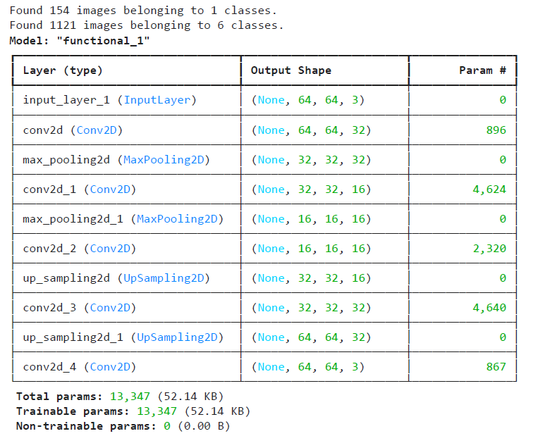

3.3 Autoencoder for Anomaly Detection
For anomaly detection, we trained a symmetric convolutional autoencoder solely on “healthy” food images. “Anomalies can be effectively detected by measuring reconstruction error, assuming that the autoencoder has only learned the distribution of normal data” [3]. The objective was to minimize the reconstruction error between the input x and its output x^ which was quantified using the mean squared error (MSE):
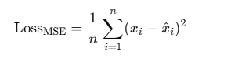
The encoder segment utilized stacked Conv2D and MaxPooling2D layers to learn a compressed representation of the input image, reducing dimensionality while preserving critical features. The decoder mirrored this structure, using UpSampling2D and Conv2D layers to reconstruct the image from the compressed encoding. The final output layer employed a sigmoid activation function to constrain pixel values between 0 and 1, consistent with the rescaled input format.
This autoencoder model was designed to reconstruct familiar (healthy) foods while producing blurred or distorted reconstructions for out-of-distribution (anomalous) items, allowing for simple and interpretable anomaly detection based on reconstruction errors.
4. Results
4.1 Transfer Learning Classification
We trained a MobileNetV2-based classifier on 27,155 training images across 80 fruit classes and evaluated it on 13,502 test images. The model achieved a test accuracy of 99.96% and a test loss of 0.0377, which indicates excellent generalization performance. Despite the model’s compact size, it effectively handled a large number of categories, thanks to the use of transfer learning and data augmentation.
4.2 Evaluation Metrics
While the MobileNetV2 classifier performed well overall, detailed analysis revealed lower precision and recall for certain classes—particularly those with visual similarities or limited training samples (e.g., apple and tomato variants). To better interpret these misclassifications, we created a focused confusion matrix (Figure 1) displaying only the 10 most frequent classes. This normalized view helps highlight which labels are most often confused with each other. To reduce the effect of class imbalance, we also applied uniform sampling during evaluation, which helped stabilize metrics across both common and rare categories.
Figure 1: Confusion matrix for top 10 classes showing strongest and weakest performance.
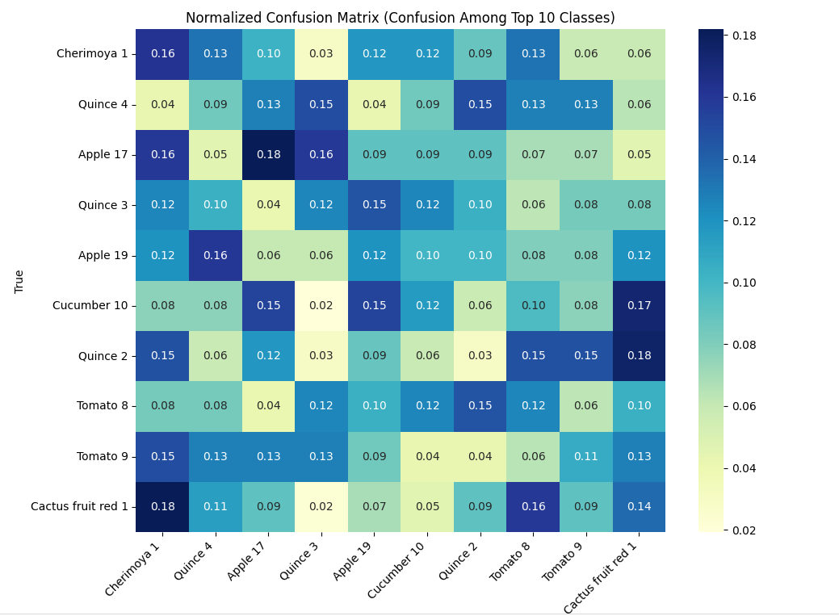
4.3 Autoencoder Reconstruction Performance
A convolutional autoencoder was trained on healthy food images (e.g., Banana 3) to learn normal patterns. The model showed consistent improvement across 20 epochs, reducing reconstruction loss from 0.11 to 0.0073. When tested on anomalous items (e.g., Beans 1, Cabbage red 1, Zucchini 1), the autoencoder produced significantly higher mean squared error (MSE) values compared to the healthy images, allowing for clear anomaly detection.
A histogram of reconstruction errors (Figure 2) shows a clear separation between healthy and anomalous samples, validating the autoencoder’s ability to detect out-of-distribution items.

Figure 2: Histogram of autoencoder reconstruction errors
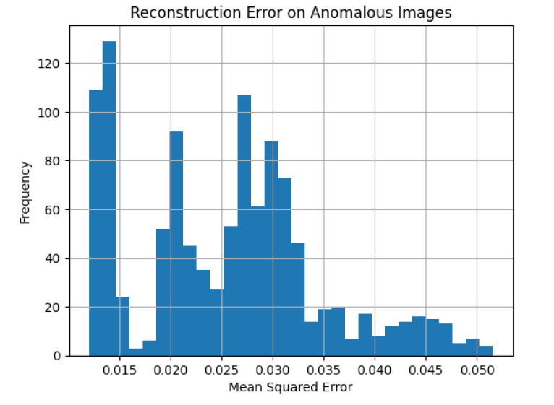
This histogram shows the distribution of reconstruction errors (mean squared error) produced by the autoencoder when tested on anomalous food images. The multiple peaks indicate variation in how well the model reconstructs different out-of-distribution samples. Most anomalies fall within an MSE range of 0.015 to 0.045, with higher errors corresponding to more distorted reconstructions. These results validate the use of a threshold (e.g., MSE > 0.01) for effective anomaly detection.

4.4 Visual Analysis
To better understand how the autoencoder performs, we visualized original vs. reconstructed images. Healthy images were reconstructed with high fidelity, while anomalous items showed distortion, blurring, or color shifts. This visual difference reinforces the use of reconstruction error as a basis for anomaly detection.
Figure 3: Original (top) vs. Reconstructed (bottom) samples
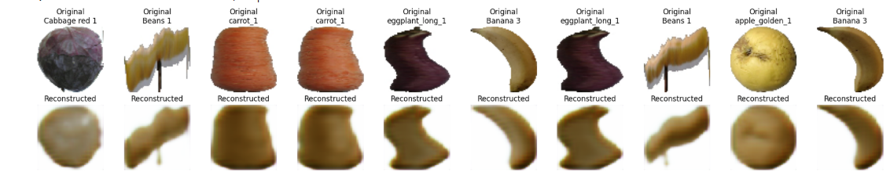
4.5. App Implementation
To provide an interactive interface for testing and demonstration purposes, we developed a web-based application using Streamlit, which “turns data scripts into shareable web apps in minutes, all in pure Python” [5]. This app allows users to upload food images, which are then evaluated by two pretrained deep learning models: a MobileNetV2 classifier for multi-class food recognition and a convolutional autoencoder for anomaly detection.
Upon uploading an image, the app performs two main tasks:
- Food Classification: The uploaded image is resized to 224×224 pixels and normalized to fit the input requirements of the MobileNetV2 model. The model returns a prediction vector, and the class with the highest softmax probability is selected. The predicted class index and corresponding confidence score are displayed to the user.
- Anomaly Detection: The same image is resized to 64×64 pixels for input into the autoencoder. The autoencoder attempts to reconstruct the image. A reconstruction loss is computed using Mean Squared Error (MSE) between the original and reconstructed image. If the MSE exceeds the threshold (set to 0.01), then the food item is flagged as anomalous, which suggests it may be out-of-distribution or unfamiliar based on the training set. Otherwise, the food is considered “healthy” or known. This result is displayed using Streamlit’s success or error message boxes. Refer to Figure 4 below.
Figure 4: Application Usage Flow
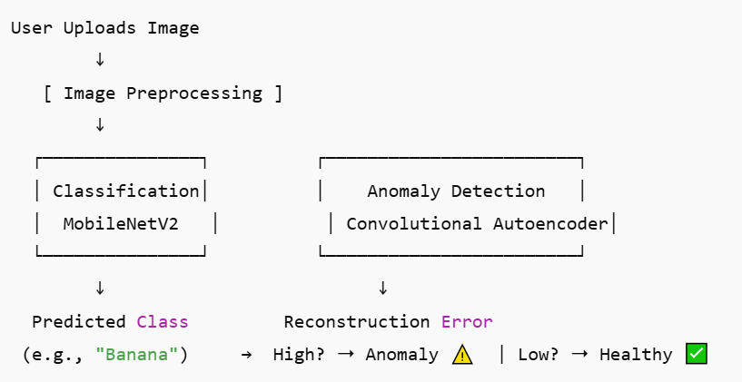
The app also visualizes the reconstructed image to allow for side-by-side comparison with the original, which gives users insight into how well the autoencoder retains food structure. The app is lightweight, interactive, and deployable via Streamlit Cloud, making it suitable for both demonstration and educational purposes.

5. Discussion
Our findings demonstrate that MobileNetV2, despite being a lightweight and computationally efficient architecture, achieved exceptional classification performance on the Fruits-360 dataset. As illustrated in Figure 5, the training and validation accuracy curves both converge toward 100% within three epochs, indicating rapid and effective learning. This is further supported by the loss curves, which show a steep decline in both training and validation loss and stabilization near zero. The minimal gap between training and validation metrics across epochs suggests that overfitting was well-controlled and the model generalized effectively to unseen samples.

Figure 5: Training Validation Accuracy and Training Validation Loss
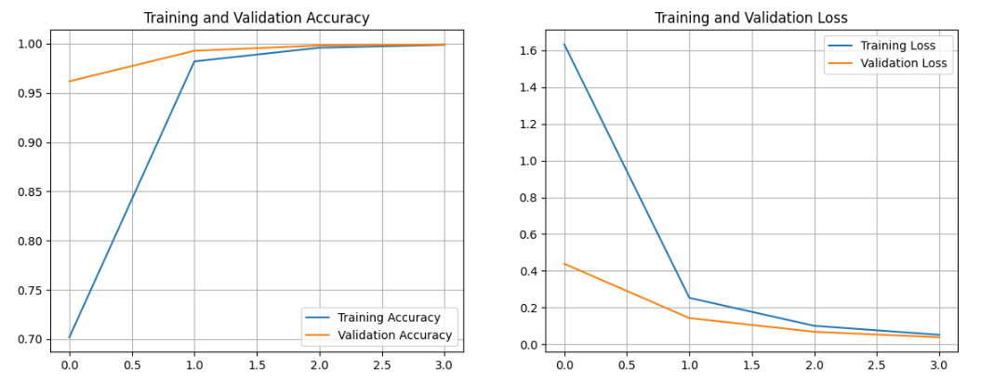
The success of this classifier can be attributed in part to the use of transfer learning with pretrained ImageNet weights, as well as the application of data augmentation. Augmentation played a key role in simulating real-world variability across fruit types and orientations, which improved the model’s robustness and mitigated class imbalance.
In the second phase of our pipeline, we implemented a convolutional autoencoder trained only on “healthy” food categories. This unsupervised model detected out-of-distribution items, such as uncommon vegetables and exotic fruits, based on reconstruction errors. The autoencoder was able to accurately reconstruct known food items while generating blurred, distorted reconstructions for anomalous inputs. This discrepancy in output, which is quantifiable via mean squared error (MSE) serves as a reliable anomaly signal.
Together, these two frameworks simulate a realistic use scenario: a classifier identifies familiar categories, while the autoencoder flags unknown or unusual inputs for manual inspection or further review. This design is particularly relevant in areas like food safety, where identifying unexpected or contaminated items is critical. This dual-model system could be extended to applications like school lunch monitoring, food delivery screening, or even allergen detection.
However, our approach has limitations. First, the assumption that high reconstruction error always corresponds to anomaly or unhealthiness may not be true in all contexts. Some visually unfamiliar but healthy foods might be incorrectly flagged as anomalies. Second, our autoencoder's sensitivity depends on careful tuning of image size, network depth, and thresholding strategies. Lastly, although the model performed well on Fruits-360, its generalizability should be validated on more diverse and complex datasets like Food-101 or real-world food photo collections.
In future work, fine-tuning the base layers of MobileNetV2, incorporating attention mechanisms, and testing on noisy or cluttered backgrounds could enhance both robustness and interpretability.

6. Conclusion and Future Work
This project illustrates how deep learning can be applied to practical food analysis by combining classification and anomaly detection in a unified system. The use of MobileNetV2 enabled fast and accurate food image classification, while the autoencoder effectively flagged unfamiliar or out-of-distribution items using reconstruction error.
Beyond model performance, the project prioritized accessibility through a Streamlit app, which allows users to easily test images and interpret results visually. This integration highlights the potential of AI not just as a research tool, but as a user-friendly solution for dietary monitoring and quality control.
Future Directions
Building on the strong foundation established in this project, future work will explore the following enhancements:
- Model Fine-Tuning: Unfreezing and fine-tuning deeper layers of MobileNetV2 to improve accuracy on novel or less-represented food categories.
- Advanced Anomaly Detection: Investigating more expressive models such as Variational Autoencoders (VAEs) and attention-based architectures to improve the detection of subtle anomalies and rare food types.
- Real-World Integration: Deploying the system as a cross-platform mobile application using TensorFlow Lite, allowing for on-device inference and offline functionality.
Overall, this project showcases how deep learning models can be effectively applied to practical problems in food analysis and health tech, laying the groundwork for smart dietary monitoring tools in the future.

References
[1] Y. LeCun, Y. Bengio, and G. Hinton, "Deep learning," *Nature*, vol. 521, no. 7553, pp. 436–444, 2015.
[2] M. Sandler, A. Howard, M. Zhu, A. Zhmoginov, and L.-C. Chen, “MobileNetV2: Inverted Residuals and Linear Bottlenecks,” in *Proc. IEEE Conf. on Computer Vision and Pattern Recognition (CVPR)*, 2018, pp. 4510–4520.
[3] J. An and S. Cho, “Variational Autoencoder based Anomaly Detection using Reconstruction Probability,” *Special Lecture on IE*, vol. 2, no. 1, pp. 1–18, 2015.
[4] H. Mureșan and M. Oltean, “Fruit recognition from images using deep learning,” *Acta Universitatis Sapientiae, Informatica*, vol. 10, no. 1, pp. 26–42, 2018. [Online]. Available: https://www.kaggle.com/datasets/moltean/fruits
[5] A. Treuille and T. Head, “Streamlit: A faster way to build and share data apps,” *Streamlit Inc.*, 2019. [Online]. Available: https://streamlit.io/
[6] A. Meyers, N. Johnston, V. Rathod, A. Korattikara, A. Gorban, N. Silberman, S. Guadarrama, G. Papandreou, J. Huang, and K. Murphy, “Im2Calories: Towards an Automated Mobile Vision Food Diary,” in *Proc. IEEE Int. Conf. on Computer Vision (ICCV)*, 2015, pp. 1233–1241.

*This work was submitted as a final project for IST 691: Deep Learning in Practice.

